ArtAwake 2010
Former First National Bank
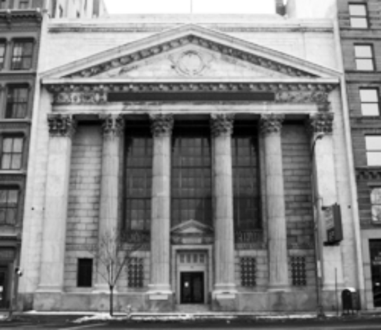
Location:
35 State Street, Downtown Rochester

Date & Time:
Saturday, April 10th, 2010, 5pm - 2am
Ticket Prices:
UR Students: $7 advance, $9 door
Students: $8 advance, $10 door
Community: $9 advance, $11 door
Advance Ticket Locations:
UR Common Market, Eastman Student Life, SUNY Geneseo, Aaron's Alley, Lakeshore Records, & the Memorial Art Gallery

ArtAwake/Midnight Ramblers Joint Ticket
$10 @ Common Market *UR Students Only

Student Busing:
UR (ITS): Looping buses from 5pm-2am
Eastman LC: Looping buses from 5pm-2am
SUNY Geneseo: Upstate Escape bus at 9pm

Recommended Parking:
Sister Cities Garage on Fitzhugh St. is right behind the bank and is free on weekends.

Music:
21 local bands of all styles and genres on 3 different stages (rock, classical, jazz, hiphop, reggae, electronica, dj's, acoustic, country, etc.)

Art:
Approximately 175 pieces of art by 105 local artists of all mediums

University of Rochester Staff :
Stacey Fisher, Assistant Director Wilson Commons Student Activities
Phone: 585-275-9393
Email : stacey.fisher@rochester.edu

Security:
Executive Security
Contact: Ernie 259-8876
Location: 3 Stephanie Ct. Rochester, NY 14468
Plan: Executive will provide 5 guards from 4:30pm to 7:00pm, 6 guards from 7-9pm, and 8 guards from 9pm-2:45am. Guards are equipted with flash lights, radios, and will be wearing black pants and black polo that say “Executive Security”.
Rochester Fire Department
Contact: Ron Lovell, Thomas Szatko
Plan: One Fire Officer will be on site the whole evening in uniform.
Food:
Tasteful Connections
Contact: Sandra Hollaway 467-4400
Providing: An artful array of light food and deserts (included in admission) and from 5-10pm Wine and Beer will be available at a cash bar
Other
-Water and Soda, Lemonade donated by DiBella’s (free)
-Coffee and Tea donated by Javas (free)
-Cupcakes provided by Little Bakery (free)
-10% off at several area restaurants with ArtAwake ticket

Special Exhibits & Installations:
Featuring interactive laser graffiti, an interactive/create your own music room, an interactive/create your own art room, an interactive camera/mirror exhibit, an eco art exhibit, a historical exhibit, & several room installations.
Bands/Musicians:
Nevergreen, Veluxe, Argus Eye, Ginger Faye Bakers, DJ LZRZ, Walri, Dave McGrath,Greg Clark Four, Coach Phase, MdotCOOP, DirectStep, 441, New Socks, Pat Gaffney, Tin Can Set, Babak Elahi, John Irrera Ensemble, Peter Kieler, Ryan McMichael, Leah Taylor, Erica Scarano

Sponsored by:
Urban Exploring*, URConcerts*, Hartnett Gallery*, Eastman SA, Eastman Student Life, NJR*, UR Class of ‘13*, Delta Upsilon, LOGOS*, WRUR*, Creative Arts*, D'Lions*, CLC*, UR Cinema Group*, UR Music Dept,, CIF*, Dibella’s, Lori’s, Maxx’s Corner, Geneseo SAA, Center for Entrepreneurship, Stellar Sound, & Javas Cafe. *Student Activities funded groups at the University of Rochester

Website:
http://www.artawake.org
UR Press Release: http://www.rochester.edu/news/show.php?id=3573
Facebook Page:
http://www.facebook.com/artawake
Facebook Event: http://www.facebook.com/event.php?eid=10150130330540527&ref=mf

Student Contacts:
Benjamin Brown, Creative Director:
Phone: (518) 683-1602 Email: info@artawake.org

Alicia Oddo, Logistical Director:
Phone: (585) 957-3025 Email: info@artawake.org

